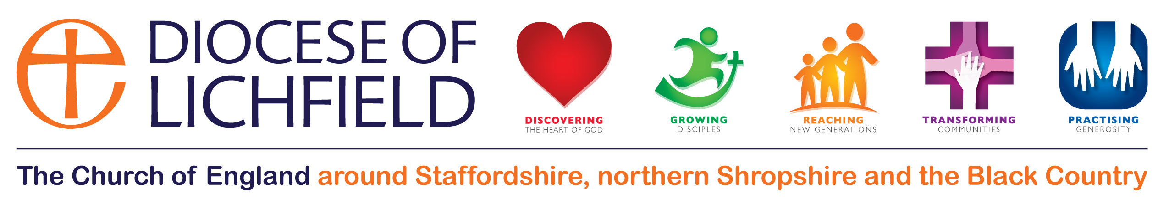
The Diocese of Lichfield
Community of Evangelists

The Lichfield Diocesan Community of Evangelists exists to recognise and affirm those with a ministry of evangelism. (lay or ordained, part-time or full time, paid or voluntary)

- We believe that God, in his love, through Jesus Christ, has reconciled us to Himself and has given us a ministry of reconciliation.
- We believe that God has called us to be evangelists and that He has equipped us by the Holy Spirit with the particular gifting to fulfil that calling.
- We believe that our call to this ministry of evangelism is a call to service in the church and the community, and we will not be motivated by a desire for personal gain. Rather we embrace a sacrificial lifestyle of availability to the direction of the Holy Spirit.

Therefore
- Our methods must stem from our conviction of the need to incarnate the Gospel, and from a recognition that all of humanity is made in the image of God, with inherent value and dignity. We will therefore avoid manipulation and coercion, acknowledging that we are fellow workers with Christ himself.
- We will work in partnership with local churches of all denominations and we will avoid anything that might undermine the ministry of local church leaders.
- Our actions will display an awareness of the importance of different contexts and cultures and a commitment to seek what God is already doing in those contexts and cultures.
- We will endeavour to ensure that those who become Christians and fully integrated into and nurtured by their local worshipping community.

Selection Criteria for membership
of the Lichfield Diocesan Community of Evangelists

Christian Life: a real and sustained experience of Christ; growth, maturity, spirituality, integrity, grace, diplomacy

Church Commitment: a communicant member of the Church of England and rooted in a local church community within the Diocese of Lichfield. Able to appreciate and work with those of differing theological and liturgical traditions.

Vocation: a clear and continuing calling to be an evangelist.

Experience of Evangelism: effective in evangelism and able to relate the Gospel to various kinds of people and situations.

Rule of Life: a member of the Community of St Chad and committed to follow the five rhythms of grace (or equivalent Rule of Life)

Balance: the demonstration of a balanced lifestyle that gives time to oneself, one’s family and friends, for rest, recreation and leisure.

Mentoring: already in possession or willing to have a mentor.

Communication: good communication skills and the ability to be flexible, creative and open to others.

Leadership: the ability to lead and to be led and the wisdom to accept criticism and to learn from experience. Tolerant of failure in self and others. Able to enthuse, attract and train others.

Supported: recommended by those who lead them and supported by their peers.

Training: there are two training events per year and you will be expected to attend at least two of these in any two year period.

Wider church: you will be expected to support mission in other parts of the diocese in prayer and may be invited to be involved as an evangelist on the team.

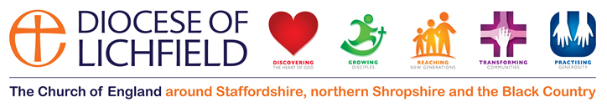
The Diocese of Lichfield
Community of Evangelists

Application Form

Your personal details
Title
First Name
Surname
Address
County
Postcode
Contact number (home)
Contact number (mobile)
Email
Date of birth

Your background and experience
Occupation / Skills
Home Church
How long have you been involved in the ministry of evangelism?
What training have you received
Do you have a mentor or spiritual director
To whom are you accountable in your ministry?
In the space provided, please write something of your own faith journey and of the difference that Christ has made in your life.

Provide examples of evangelism you have been engaged in and what you are currently doing.

Recognition of your ministry
Does your application have the support of your Vicar?
Does your application have the support of your PCC?

We would ask you to provide us with the details of 2 people who could act as referees if so required. They should know you well and be able to say something about your ability to establish and maintain personal relationships, your spiritual life and your pattern of worship as well as something about how you have fulfilled your existing commitments in ministry. We will also seek the views of your Vicar, Rural Dean or Archdeacon.

Referee 1
First Name
Surname
Address
County
Postcode
Email

Referee 2
First Name
Surname
Address
County
Postcode
Email

We will be expected to have DBS clearance for any aspect of evangelistic work for which it would be needed.
Please return the completed form to Lynne Mills, Warden of Lichfield Diocese Community of Evangelists, lynne@fpe-network.org 27A Tower View Road, Great Wyrley, Walsall, West Midlands. WS6 6HF.

