

A Handbook for Curates
&
Training Incumbents
2026-27
IME Phase 2
Welcome to ordained ministry in partnership with all God’s people in Lichfield Diocese
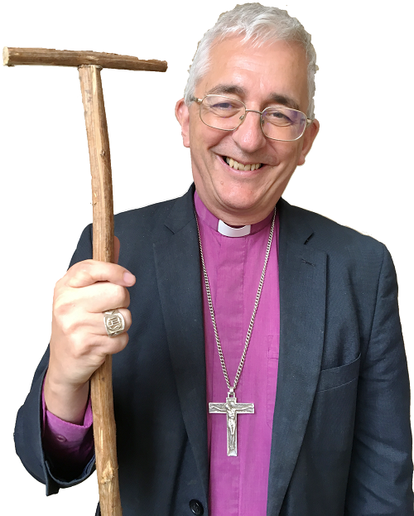
‘Will you be diligent in prayer, in reading Holy Scripture, and in all studies that will deepen your faith and fit you to bear witness to the truth of the gospel?’ That is the question which you will be asked at your ordination whether as deacon or as priest, and your answer will be: ‘By the help of God, I will’. The question and promise are a powerful reminder of the lifelong learning and formation that must underpin our ministry as deacons and priests. That commitment to education is particularly crucial in the years immediately following ordination, when the habits of a lifetime of service of God and God’s people are being formed in us.

In the Diocese of Lichfield, we take that commitment very seriously. My expectation is that you in turn will make a correspondingly strong commitment, prioritising IME meetings and events, and entering fully into the shared learning which lies at their heart. The guidance we receive from the Holy Scriptures speaks to us with a fresh vigour and directness when we prayerfully integrate our studies with the everyday realities we are encountering in our ministerial service, and when we are opened up to insights from one another too. I am glad that IME phase 2 in this diocese is delivered through a framework that is biblical, contextual and ecclesial; my hope is that through your whole-hearted participation in this programme you will find your excitement is constantly in learning more and more of the mysteries of God’s loving purposes in Christ. May what was said of the Jewish communities of Eastern Europe be said of the curates of Lichfield: ‘They get drunk with the love of learning in the way that other people get drunk with the love of wine’.



Index

Welcome to Your Curacy in the Diocese of Lichfield 4
The Values of IME2 5
Key Contacts 6
Curacy in the Diocese of Lichfield 7
The Shape of a Curacy 8
Terms and Conditions 9
Wellbeing Resources 10
The IME2 Programme for those ordained Deacon in 2026 11
IME 2 Programme Outline 12
Additional IME2 Elements 14
Pastoral Supervision 14
Curate Reflective Practice Groups 14
Undertaking Further Studies 14
Working with your Training Incumbent 15
Beginning with Your Training Incumbent 15
Working Together 16
Beginning in the Parish 18
Assessment of Curacy 19
Annual Portfolios 19
The Mid-Term Assessment 20
Completion of Curacy 21
Non-completion of curacy 21
Moving on 22
Appendix 1: Diocesan Directory 23
Appendix 2: Other Key Roles and Resources 26

Welcome to Your Curacy in the Diocese of Lichfield
I am delighted to welcome you as you begin your curacy in the Diocese of Lichfield.
Your curacy is a gift from God offering the space, time and support for you to grow in the ministry to which you have been called. Here, in a supportive environment, you are given the opportunity to learn, grow and discover as you begin the journey of your ordained vocation.
Like many gifts, your curacy is also a responsibility, to ensure that you wisely make the most of this experience as you learn what it is to serve the church that God loves and has called into being.
How will you make the most of this gift?
Our desire over these coming years is to work with you to make the most of this gift so that you develop the qualities, skills, awareness and disciplines that prepare, resource and sustain you in the long term and allow you to serve and release those to whom God calls you. At times we recognise curacy may not feel like a gift, maybe more of a burden. However, you are not part of a mechanical process, so please do know that we are available to you, willing to support and engage with you.
During IME2 you will undertake training and assessment within the Diocese as you engage in ministry under the supervision of your Training Incumbent and as part of a group of curates. Most of your formation and learning will take place in the local church as you gain everyday ministerial experience. I very much hope that this will be a rich and rewarding experience both for yourself and for those you are called to serve. Alongside this is the more formal training that the diocese provides, and for which I have overall responsibility.
Supporting me in the delivery of IME2 training is Mrs Angela Bruno. Angela gives administrative support and will often be communicating with you about the programme and diocesan matters. In addition, Revd Canon Dr Georgina Byrne of the Queen’s Foundation acts as Director of Studies for all curates continuing with accredited study through the Queen’s Foundation.
Our role over the next few years alongside your Training Incumbent and Parish is to provide the opportunities for ministry, learning and reflection that will prepare you well for moving into Assistant or Incumbent ministry posts in the future.
It is a privilege to accompany you on this journey and my prayer for you is that in these coming months and years you will rejoice in the gifts you have been given and even more rejoice in Christ, the giver of those gifts.
The Revd Ben Care
Initial Ministerial Development Officer

The Values of IME2
Five Core Values underpin our work with Curates and Training Incumbents. These express our ethos, our commitment and in turn hope will be passed on to others:
- Pleasing God above all
- We worship & seek to walk in step with Jesus as Lord of IME2.
- We delight to work for the service of Christ and his Church.
- We approach the training in a spirit of freedom and creativity.
- We are willing to have difficult conversations and not leave things for others in the future.
- We ensure IME2 is gospel-promoting, gospel-centred & gospel-driven (saying and showing the good news).
- Radical Valuing
- We glory and rejoice in Curates in this Diocese and work for the good that Christ desires for each curate.
- We know our curates as whole people & invite them to bring their life experience and wisdom.
- We encourage curates to own their IME2 experience.
- We make training relevant to the needs, challenges & opportunities of church leadership today.
- We invite a diversity of voices & encourage learning alongside others.
- Delight in Transparency & Integrity
- We offer consistency & keep confidentiality
- We cultivate an atmosphere of honesty, trust, accountability and openness.
- We acknowledge and do not cover up when mistakes are made & outline steps to prevent future occurrences.
- Passionate Commitment & Service
- We are relational and not functional.
- We create an environment that is safe for all.
- We guard against unnecessary burdens or creating barriers.
- We make IME2 an engaged, responsive & active process – listening and looking for improvement.
- Active Availability
- We go the extra mile in supporting our curates & being available to them.
- We do not do training to people, but with them. Look for creative means of engaging people in what a creative, affirming process.
- We look for ways of increasing access to training.

Key Contacts
https://www.lichfield.anglican.org/vocations-and-training/
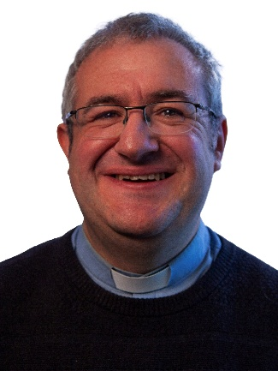 | The Revd Ben Care  Initial Ministerial Development Officer  ben.care@lichfield.anglican.org  07376 525391
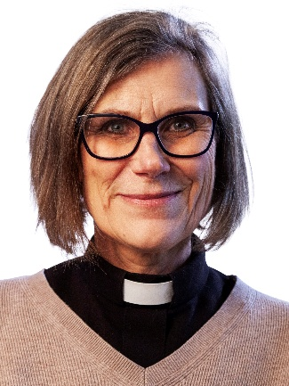 | The Revd Preb Dr Jeanette Hartwell  Director of Ministry  jeanette.hartwell@lichfield.anglican.org
 | Mrs Angela Bruno  Executive Assistant to the Vocations Officer  angela.bruno@lichfield.anglican.org
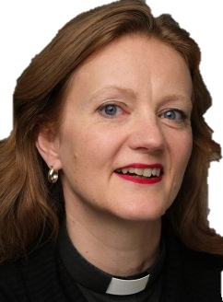 | The Revd Dr Georgina Byrne  Anglican Director of Studies at the Queen’s Foundation  byrneg@queens.ac.uk

Curacy in the Diocese of Lichfield
You are serving your curacy in one of the most diverse dioceses in the country. Rolling countryside and vibrant inner-city life nestle together in a region that takes in Staffordshire, the Potteries of Stoke-on-Trent, most of Shropshire and bustling Black Country centres including Walsall and Wolverhampton.

We serve a population of over 2 million people - the fifth largest diocese in the country - and an area of 1,740 square miles. There are over 540 churches in 422 parishes with around 500 clergy - plus over 200 Church schools and academies.

Seeking the Kingdom: The Strategic Plan
In 2024 Diocesan Synod adopted the strategic plan that determines the direction and goals of the Diocese until 2030. Ten goals have been agreed, they are:
- a growth in the overall worshipping community of 34,000 new disciples
- 200 new worshipping Communities which are established and sustainable
- a strengthened culture of vocation amongst all God’s people, and at least 30 new licensed lay ministers and 30 ordinations a year
- an active plan in every parish for engaging with their local population beyond the church walls a strong connection between every primary or secondary school and their parish church
- no fewer than 30 young people per year aged between 18 and 30 who are called to leadership being supported through a high-quality development programme offered by the diocese
- the age profile of each worshipping community reflecting the age profile of the community which it serves
- every worshipping community reflecting the diversity of the community they serve
- all people being able to see themselves reflected in the leadership and governance of the diocese
- to have made substantial progress towards Net Zero Carbon with a clear and achievable plan of how any shortfall will be resolved in the following few years

Our strategy or plan for the journey towards our vision is that together we will focus on Feeding our Faith, Supporting our Ministry, and Building up our Parishes and Communities. This will immerse us in celebrating and investing in the existing pattern and practice of our ministry – parishes, schools, fresh expressions, chaplaincies and the cathedral, as well as identifying opportunities to try new ways of being church. At the same time, it will mean taking a careful and honest look at where we are, who we are and what we are doing, noting what is working and what may not be working, and seeing what we could do better. We should not carry on doing things just because ‘that’s the way we’ve always done them’, but neither will we turn our backs on all that is distinctive, good and fruitful.
The Diocese of Lichfield is committed to equipping our curates for their future ministries by fully aligning our IME programme with our strategy.
More information on the Diocesan Strategy can be found in Seeking the Kingdom.

The Shape of a Curacy
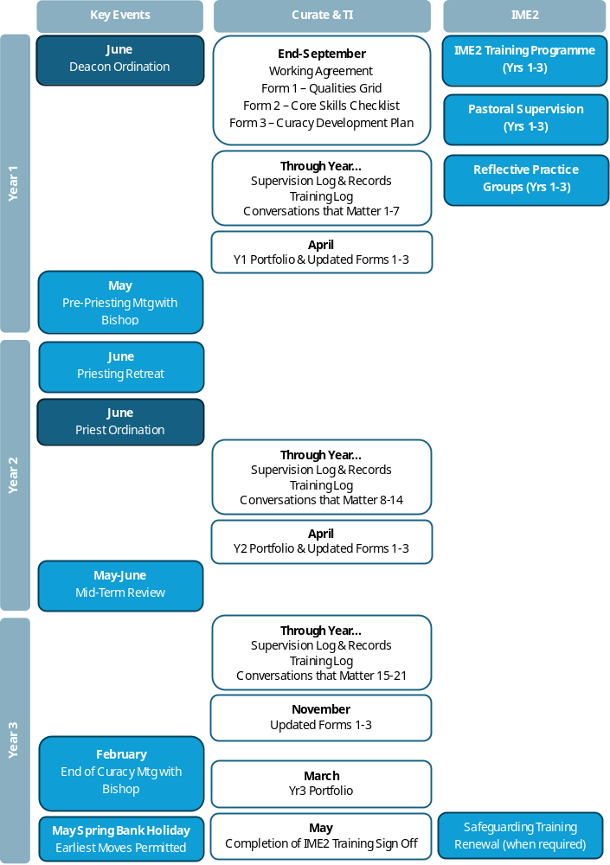

Terms and Conditions
Safeguarding & DBS
All curates in the Diocese of Lichfield are expected to be attentive to the legal and diocesan requirements concerning the safeguarding of children and vulnerable adults. Within the current guidelines for best practice ordinands are required to have completed the Safeguarding Leadership, Raising Awareness of Domestic Abuse, and Safer Recruitment and People Management modules prior to ordination as a deacon and to renew their training prior to completion of their curacy within the Diocese of Lichfield.
All clergy holding the Bishop’s licence are expected to be familiar with the Guidelines for the Professional Conduct of the Clergy.
Each curate must be fully introduced to policies around child and vulnerable adult protection in their placement context.
Common Tenure
Common Tenure is the form of office holding introduced by the Ecclesiastical Offices (Terms of Service) Measure 2009. Common tenure applies to both stipendiary and self-supporting priests. Under Regulation 29, some common tenure posts are time limited and this is known as Qualified Common Tenure. This applies to curates as yours is a training post.
Statement of Particulars
Issued by the Chief Executive Officer’s office a Statement of Particulars sets out the terms and conditions on which your appointment is to be made, and will include:
- The details of the entitlement to stipend, fees, and reimbursement of expenses
- Terms and conditions relating to rest periods and holidays (including annual holiday entitlement, Sundays on which leave may be taken, and the public and special leave days on which leave may not be taken)
- Terms and conditions relating to sickness absence and long-term absence
- Pension provision
- Statutory rights (including maternity, paternity, parental and adoption leave)
- Right to time off to care for dependents
- An itemised monthly stipend statement
- Links to the processes, guidelines and policies which underpin the roles and responsibilities of clergy within the diocese.

Assistant/Incumbent Status Ministry
Curates will have originally been selected for training as either an Assistant or Incumbent status minister and the assessment of curacy reflects this. The curate should be aware of the category for which they were originally sponsored. If there is any doubt, then they should seek clarification from the Vocations Officer or Ben Care.
Occasionally, an Assistant minister curate may feel prompted to explore a change in category of ministry from the one for which they were originally sponsored (e.g. to Incumbent status ministry). This should be discussed with Ben Care in the first instance. It should be noted that the diocese will not normally agree to such a change during curacy as it is expected that the original commitment should be fulfilled. However, in exceptional circumstances, the option may be explored in the latter stages of a curacy and the process involves the candidate attending a national or diocesan candidate’s panel and requires the approval of the Diocesan Bishop.
Any subsequent change in category usually requires the curate to serve an additional curacy.
Duration of Curacy
Curacies for full-time stipendiary curates in this diocese are for four years. This means that the diocese is committed to providing a stipend and housing right up to the end of the fourth year of the curacy, though the end of curacy assessment comes at the end of the third year.
For Self-Supporting curates the normal length of a curacy is five years.
A curacy may be extended because of maternity leave or another long-term absence.

Wellbeing Resources
The wellbeing of clergy is the responsibility of the whole people of God. The Diocese of Lichfield takes seriously its responsibility to support its clergy and their families and provides a wide range of resource which can be accessed. These resources are available as a means of establishing good habits for sustainable ministry, early intervention and aid in more acute cases. Details of the provision can be found on the Diocesan website: www.lichfield.anglican.org/pastoral-care-and-wellbeing/

The IME2 Programme for those ordained Deacon in 2026
The IME2 programme has been designed to resource curates with foundational understanding for key aspects of ministry and provides an opportunity to learn from those who have lots of experience. This programme complements the training and support offered locally under the supervision of the training incumbent. IME2 sessions prioritise the development of curates’ understanding and encourage reflection on practice. The programme seeks to help curates develop in seven areas:
- Compliance with legal rules and regulations
- Clarity about roles and expectations
- Confidence in inhabiting public-ministry
- Connection with colleagues and developing team ministry
- Culture awareness understanding the mission, vision, and values of the church and the wider diocese
- Conviction that you want to do ministry well
- Christ-dependence remembering the greatness of the trust in which you share, the ministry of Christ himself
Attendance at the whole of the programme is compulsory for curates preparing for Incumbent status ministry; attendance at compulsory core events (including residentials) is required for those preparing to be Assistant Ministers, although they are welcome to attend any sessions.
Please put the dates in your diary now and make sure your Training Incumbent is aware of them too. When a day clashes with a day off, an alternative day off should be taken. As far as possible, arrange holidays so that they do not clash with IME2 study days or residentials.
If you are unable to attend a study day or residential because of illness, please let Ben Care know as soon as possible. Note that if you do miss a study day or residential because of illness or holiday then you may need to provide evidence that you meet the formation framework in another way.
In addition to the IME2 programme, all curates are welcome to attend other diocesan and external training events as they wish (in consultation with their TI). As a minimum it is expected that curates will attend 8 optional study days over the course of their curacy.
Incumbent status curates are also expected to attend Bishop’s Continuing Ministry Development (CMD) days, the Annual Selwyn Lecture at the Cathedral (usually in the autumn) and the Bishop’s Clergy Conference (held every two or three years). Other curates are invited to attend these events as is practicable.
Details of training events offered by the Diocese can be found here: https://www.lichfield.anglican.org/vocations-and-training/training/

IME 2 Programme Outline
Year 1 2026- 27
Deacon Induction Day (with TIs) | Tuesday 30th June 2026 10am – 4pm Shallowford
Beginning Well | Saturday 10th October 2026 10am – 4pm Shallowford
Holding Office Well: Common Tenure, Professional Conduct and Clergy Discipline | Thursday 19th November 2026 10am – 4pm Shallowford
Leading Teams | Saturday 23rd January 2027 Queens Foundation
Preparing for Priesthood | Thursday 11th March 2027 10am – 4pm Shallowford
Legalities of Weddings | Wednesday 12th May 2027 3-4pm (Zoom)
Who am I as a Leader? | Thursday 20th May 2027 10am – 4pm Shallowford
Optional Study Days 1 & 2 (to be selected from the diocesan suite of training)

Year 2 2027-28
Priest Retreat | June 2027
Unconscious Bias | November 2027
Stewarding Parishes Well: Charity Law, Parish Governance and Church Buildings | November 2027
Into all the Parish | Friday 5th – Sunday 7th February 2028
Effective Conversations | March 2028
Leading the Whole Church | May 2028
Optional Study Day 3, 4 and 5 (to be selected from the diocesan suite of training)

Year 3 2028-29
Mental Health and Well-Being | October 2028
Moving On | October/November 2028
Ordered for a Purpose: Canon Law and the Mission of the Church | November 2028
Working with Difficult People | January 2029
Going the Distance | March 2029
Safeguarding Training Renewal | To be completed when renewal required.
Optional Study Days 6, 7 and 8 (to be selected from the diocesan suite of training)
Please note dates from July 2027 onwards are approximate and may be moved.

Additional IME2 Elements

Pastoral Supervision
Lichfield Diocese takes seriously clergy wellbeing and the joys and tensions that inhabiting the ordained life can bring. To that end we wish to support you as fully as possible in these early stages of your ordained ministry.
All curates (Incumbent and Assistant) joining the diocese are expected to participate in Pastoral Supervision throughout their curacy. Pastoral supervision provides the opportunity to meet regularly with an independent third party to reflect on your ministry. It offers a confidential one-to-one conversation and is completely outside of any diocesan reporting process. Pastoral supervision allows curates the space to grow in understanding and spiritual insight, increases pastoral skill and facilitates growth in response to challenge. Each curate will have a pastoral supervisor allocated to them in the first months of curacy.

Curate Reflective Practice Groups
Curate Reflective Practice Groups are created for mutual support and encouragement. They offer a reflective, confidential space outside of the primary parish or ministerial setting. Their purpose is to enable and deepen reflection on ministerial experience in the context of peer learning and support in order to enable curates to understand and change their own practice in the light of the shared theological wisdom of the group.
The groups consist of a maximum of four curates (usually within an episcopal area). Facilitation of the group is the responsibility of the members. You are encouraged to establish a regular pattern of meetings and to establish appropriate mutual commitment and accountability.

Undertaking Further Studies
Alongside completion of the IME 2 programme curates are welcome to consider completing further study during their curacy. If a curate wishes to complete a BA (Hons) under Common Awards through the Queen’s Foundation this is encouraged by the diocese as a means of strengthening confidence and knowledge in core disciplines and as an encouragement to lifelong learning. As part of its commitment to this priority the diocese is willing to fund this route of additional learning. Curates are also welcome to consider building on prior learning in a specialist subject by undertaking post graduate studies with Queen’s or elsewhere. All curates wishing to undertake further studies at whatever level should have an initial discussion with Ben Care.

Working with your Training Incumbent
A successful curacy is not only about the formal learning that takes place but of primary importance is the relationship between the curate and Training Incumbent. While this relationship is essentially that of colleagues sharing responsibility for leadership in a local Christian community, it will inevitably change over time as the curate’s experience and confidence grows.
Curates and Training Incumbents are encouraged to work together to establish a shape for each curacy, enabling curates to cover a wide range of ministerial opportunities over their curacy. Part-time curates will need to find the best way to use their available time to encompass the full range of ministerial experience.
It is important to highlight that this is a training relationship, and while it may move towards equality it is never equal and it is misleading to pretend that it is. The Training Incumbent carries responsibility for ensuring that their curate develops in character and skills, gains the necessary competence to carry out the work of an ordained minister to which they may be called, and shares responsibility for assessing this growth in character, skill, and competence over at least a three-year period with diocesan colleagues under the oversight of the bishop.
From the beginning, it is important to be clear about the role of power in the relationship between you. Power is held between an incumbent and curate asymmetrically, which is to say that the incumbent is more powerful than the curate.
In establishing and developing a professional and mutually supportive working relationship the following points are given high priority.

Beginning with Your Training Incumbent
Information shared with the Training Incumbent. The curate will arrive having received a Final Report from the theological college or course. The training incumbent will be sent a copy of this report by the Vocations Officer, and should use it, in consultation with the curate, to look at training needs.
The Training Incumbent will not automatically have been informed about additional needs or access requirements. The curate should determine what information they feel it is necessary and comfortable to share in order to facilitate a positive working relationship.
Working Agreement. When a new curate arrives priority attention should be given to formalising the Working Agreement to the satisfaction of both parties. The working agreement can be started before the curate arrives but should be completed within the first three months after ordination. Curates and Training Incumbents should be open and honest in exploring together and setting expectations.
At all stages prior to assessment at the end of curacy, the Working Agreement should be regularly reviewed to see if it requires any amendment.
Learning Agreement. Curates and TIs are expected to work together to identify the priorities for the curate’s learning for each year of curacy.

Working Together
Regular worship and prayer together. Patterns of prayer will vary within local teams and traditions but there is an expectation that the curate and TI will meet for regular worship and prayer.
Supervision. Regular time for the supervision of ministry must be allocated. This is a distinct process separate from the staff meeting agenda. Its purpose is training, and its focus will be on reflecting theologically on ministry within the parish, reviewing aspects of the curate’s ministry, and exploring areas of concern in his/her ministerial development. Some of this will be framed by an advance agreed agenda (e.g. check through the Formation Framework or review the Learning Agreement). Space should be given for the curate to come with their own questions and reflections. Written notes of supervision meetings must be made, agreed and kept.
A weekly supervision session is essential for those in full time ministry within the parish, particularly in the first year, reducing, in a manner appropriate to the local situation, to monthly by the end of the curacy. For those offering less than fulltime ministry supervision sessions should be at least monthly.
Entering ordained ministry demands considerable adjustments to home, family and social life. Establishing healthy working patterns should be discussed regularly at supervision.
Conversations That Make A Difference. As part of their supervisions, Curates need to complete 18 reflective conversations during their curacy. The reflections have two parts. Firstly, a semi-structured conversation between yourself and your Training Incumbent held as part of your supervision. Secondly, a written reflection which could be prepared before your supervision session and brought with you to aid discussion with your TI, or put together after you have reflected verbally with your TI. These written reflections will form part of your portfolio.
Further details can be found in the Conversations That Make A Difference document.
Staff Meetings. A regular staff meeting is essential and cannot be satisfactorily replaced by a short chat after the daily office. This should be weekly with fulltime staff and at convenient intervals for others, but never less than once per month. The meeting will include a review of the past week, forward planning for next week, exchange of pastoral information and detailed arrangements for coming events or responsibilities.
One area where the curate may especially appreciate help is in realistic planning of the daily and weekly programme. The Training Incumbent should be prepared to share his or her experience (warts and all!) and enable their colleague to divide time realistically with reasonable space for reading, prayer and single/family life issues - as well as parish commitments.
Personal Reflection and Study Day. A regular study day should be agreed. This will be essential for successful completion of the requirements of IME2. It should not be used for matters such as preparing sermons or house group material. For some parishes and curates, a 5-day study week every 5 weeks serves this purpose better than individual study days. This is a matter for local agreement. Where study days are lost at times of pressure, these must be allocated to a later date (e.g. study days lost in Advent could form a study week early in the new year). In total the curates should receive 46 study days per year. Curates’ residential weekends are in addition to this.
Both training incumbent and curate will receive at the time of ordination a list of dates for IME2 Events. They should plan these together in their diaries. All these activities are regarded by the diocese as mandatory in the first three years. Absence for illness should be reported to Ben Care.
Support for the Training Relationship. While every effort is made to ensure that curacies are successful, it is not unusual for curates and Training Incumbents to experience difficulties of one kind or another during curacy.
Clear expectations, along with regular supervision sessions, are key to providing opportunities for issues to be discussed in an open, honest and respectful manner. Matters of concern should be raised at the earliest opportunity and each party should take responsibility for what they find difficult and challenging and offer a potential way forward for discussion.
Lack of respect, bullying, harassment and discrimination have no place and will not be tolerated in the Diocese of Lichfield. The Dignity at Work Policy sets out the framework in which bullying and harassment can be defined, recognised and reported.
Early support is essential when the relationship is facing difficulties, and Ben Care should be contacted by either curate or incumbent. Depending on the nature of the concern an appropriate course of action will be determined which may involve other senior members of diocesan staff being informed of the situation.

Beginning in the Parish
Prior to beginning
The Training Incumbent will communicate to church wardens, PCC, congregation and relevant others that the curate is in a training post and as such is not ‘an extra pair of hands’, rather that significant time will need to be given to train, supervise and support the curate.
Reading the Curate’s Licence to the Congregation
Because the curate will have been ordained and given their licence in the Cathedral rather than in one of the churches in which they are to serve, the Curate’s Licence needs to be read in front of the congregation on the first Sunday they are present in one of the churches in which they are to serve.
First weeks in the Parish
In the first weeks, the Training Incumbent should…
- Make sure the curate has access to all the relevant parish policies (e.g. safeguarding, GDPR, Mission Action Plan) and time is given to read and discuss them.
- Explain how the Parish Registers are kept and how other parish information is recorded.
- Make sure the curate is on mailing lists for clergy chapter, deanery synod, local ecumenical gatherings, and is aware of meeting dates.
- Make sure the curate meets with key people/staff in the congregation, including church wardens and any leaders in the wider community.
- Where there is a parish office staffed by a PA or administrator, communicate clearly to the curate what their relationship to this person should be and any administrative support they can expect.
- Make sure the curate has a set of keys to the church building. This should include a Health & Safety briefing and a fire briefing for the premises.
Ministry in the Parish
In the initial period, curates should spend time getting to know the wider community. Those who are full-time in their context will usually be taking funerals on their own within the first two to three months of ordination. The normal role of a deacon at baptism would be to assist the priest, although deacons may take baptisms in cases of pastoral need – which might, for example, be in the case of a strong pastoral relationship (and if no priest is present). Similarly, deacons would not normally take weddings but may be part of wedding visits or preparation in readiness for stepping into this ministry soon after ordination as priests.

Assessment of Curacy
The House of Bishops requires all curates to show evidence of their engagement with key formation qualities and capability in core skills to continue in ministry. The Qualities describe a life-long journey of faith in which the minister’s life is progressively transformed in the steps of Christ. They also describe the habit of life the Church requires of its representative ministers. your curacy provides a framework within which you can grow in inhabiting the seven formation Qualities (Love for God, Call to Ministry, Love for People, Wisdom, Fruitfulness, Potential, Trustworthiness) exercised across the Four domains (Christ, Church, World, Self).
It is the responsibility of the curate, with the help of the Training Incumbent, to ensure that they have evidence to show that they inhabit each of these qualities competently by the end of their curacy: careful planning to achieve this aim is strongly encouraged at the outset and during the curacy.
Further details can be found on the Church of England Website:
IME2 Priest qualities and evidence
IME2 Priest PIONEER qualities and evidence
IME2 Distinctive Deacon qualities and evidence

Annual Portfolios
It is the curate’s responsibility to provide sufficient evidence that the formation framework has been met. To facilitate the careful and consistent gathering of the required evidence each year the curate is expected to submit a portfolio of evidence, as follows:

Year 1
- Log of supervision meetings with Training Incumbent
- Log of attendance at IME 2 and CMD events
- Conversations That Matter 1-6
- Form 1 – Summary Curacy Assessment Document
- Form 2 – Core Skills Checklist
- Form 3 – Curacy Development Plan

Year 2
- Log of supervision meetings with Training Incumbent
- Log of attendance at IME 2 and CMD events
- Conversations That Matter 7-12
- Form 1 – Summary Curacy Assessment Document (Updated)
- Form 2 – Core Skills Checklist (Updated)
- Form 3 – Curacy Development Plan (Updated)

Year 3
- Log of supervision meetings with Training Incumbent
- Log of attendance at IME 2 and CMD events
- Completed Additional Training requirements
- Conversations that Matter 13-18
- Form 1 – Summary Curacy Assessment Document (Updated)
- Form 2 – Core Skills Checklist (Updated)
- Form 3 – Curacy Development Plan (Updated)
The Portfolio is required to be submitted each year of curacy and will be reviewed by Ben Care who will identify key areas for learning.
All reports and documents are available on the diocesan website here: https://www.lichfield.anglican.org/vocations-and-training/curates/curates-training/
Further details and guidance for each of the elements of the portfolio will be provided, but please do ask if you have any questions.

The Mid-Term Assessment
The key point for assessment against the formation framework is the Mid-Term Assessment and occurs towards the end of Year 2 of curacy, although a curate may choose in consultation with their TI to postpone the process until Year 3. For curates serving part-time curacies (Incumbent or Assistant ministry) of less than 15 hours per week, the Mid-Term assessment takes place towards the end of year 3 of curacy. The Mid-Term Assessment process incorporates 360-degree review and the portfolio (including feedback from diocesan officers on assignments) is submitted to a Bishop’s Assessor, who is one of a panel of assessors chosen by the Area Bishops. The purpose of this assessment is fourfold:
- to enable discernment to be made about the curate’s fitness to move beyond IME 2 to a position of further responsibility as an assistant or incumbent status minister.
- to discern continuing and emerging gifts/ministries – including areas of potential for ministry.
- to determine priorities for issues of further training and experience in the curacy that remains.
- to offer guidance as to where future ministry might lie.

Curates and Training Incumbents are expected to pay particular attention to the training requirements identified in the Mid Term Assessment Report to meet the formation framework before the end of the curacy.

Completion of Curacy
All curates are required to provide evidence that they satisfy national Church of England standards of ministry for Common Tenure, in such a way that their Diocesan Bishop is confident to commend them. Suitability of any curate for Common Tenure Primary Responsibility/Assistant Ministry/Pioneer Ministry is the decision of the Diocesan Bishop. In the Diocese of Lichfield, the Area Bishop, advised by the Initial Ministerial Development Officer and Director of Ministry, will assess whether a curate has met the required standards. Where appropriate, the Area Bishop may consult with the bishop with responsibility for extended pastoral and sacramental oversight. The formation and assessment process is designed to evidence and advise Bishops of the curate’s suitability. The final decision on Common Tenure suitability rests in all cases with the Diocesan Bishop.
Following successful completion of the Mid-term Assessment and Final Year reports curates are invited to meet with their Area Bishop for their ‘end of curacy meeting’ in the spring term of the 3rd year of curacy (the following year if the Mid-term Assessment has been postponed). The Area Bishop should always be informed and consulted about any personal initiatives or approaches from others regarding moving on. Curates should not ask for permission to apply for a post prior to the ‘end of curacy’ conversation as the Area Bishop is, at that stage, unable to provide a satisfactory reference. Ordinarily curates will not be licensed to a new post before the end of three years of curacy (July of year 3) at the earliest. Moves are permitted from the May Spring bank holiday week onwards.
Curates trained for Incumbent status ministry can apply for Primary Posts of Responsibility or Assistant posts (parish, chaplaincy etc).
Curates trained for Assistant Minister posts may consider the following options:
- Remaining in the present post as Associate Minister or Priest.
- Moving to a new parish as Associate Minister or Priest.
- Applying for a ‘house for duty’ or other stipendiary post of Assistant capacity.
- Changing category to stipendiary or SSM incumbent status ministry. This will only happen after a due process of discernment (which will probably require the candidate to undertake further training), the recommendation of a Candidates Panel and the Bishop of Lichfield’s approval.

Non-completion of curacy
Curates who do not satisfy the formation framework for Common Tenure, will receive notification from their Area Bishop identifying the areas where they have failed to meet the framework. In such circumstances the training post will come to an end at the expiry of the license because of the time-limited nature of the post. The responsibility for the next step for such Curates will be with the person themselves, although the Area Bishop, supported by Bishop’s Officers, will want to give the curate appropriate support as they look for other types of employment or training and/or other avenues for service.
A curate for whom the Area Bishop is not willing to write a recommendation for Common Tenure has the option to request the Diocesan Bishop to reconsider the decision through an appeal process. The Formation and Assessment in Curacy: Appeals Procedure can be found here - Curacy Appeals Procedure

Moving on
When the curate has accepted an offer of a post a date for licensing/institution is usually agreed mutually with the curate and the receiving bishop (whether in the Diocese of Lichfield or elsewhere). Ordinarily a period of 2-3 weeks is granted for moving and the curate should negotiate a suitable leaving date with the TI (taking account of any outstanding annual leave entitlement). The curate should write to the Diocesan Bishop (with a copy to the Area Bishop and the Initial Ministerial Development Officer) effectively resigning from the training post and advising them of the date of licensing and intended date of departure. The bishop’s office raises internal documentation (the ‘chit’) which notifies the relevant diocesan departments of the impending move.
Incumbent Status curates entering their fourth year of curacy who have not secured a First Post of Responsibility will receive a letter from their Archdeacon in the autumn of their fourth year advising the date (the end of the license) when their stipend and entitlement to live in housing provided by the diocese will cease. In cases where there are school-age children living in the property the entitlement to housing may be extended to accommodate the end of the academic year.

Appendix 1: Diocesan Directory

Website www.lichfield.anglican.org

Bishops and Archdeacons
Bishop of Lichfield The Rt Revd Dr Michael Ipgrave OBE bishop.lichfield@anglican.org
Bishop’s PA Sally Churchill sally.churchill@lichfield.anglican.org

Chaplain to the Bishop of Lichfield The Revd Treena Larkin
treena.larkin@lichfield.anglican.org
Bishop of Oswestry The Rt Revd Paul Thomas bishop@seeofoswestry.org.uk
Bishop of Ebbsfleet The Rt Revd Rob Munro admin@bishopofebbsfleet.org

Shrewsbury Episcopal Area
Bishop of Shrewsbury The Rt Revd Sarah Bullock bishop.shrewsbury@lichfield.anglican.org
Bishop’s PA Carole Markham admin.shrewsbury@lichfield.anglican.org

Archdeacon of Salop The Ven Nick Watson archdeacon.salop@lichfield.anglican.org
Associate Archdeacons of Salop
Revd. Jo Farnworth AAD.salop@lichfield.anglican.org

Revd. Mary Thomas bawm@lichfield.anglican.org
Archdeacon’s PA Simon Cartlidge simon.cartlidge@lichfield.anglican.org

Stafford Episcopal Area
Bishop of Stafford The Rt Revd Matthew Parker bishop.stafford@lichfield.anglican.org
Bishop’s PA Gemma Trueman gemma.trueman@lichfield.anglican.org
Archdeacon of Stoke-upon-Trent The Ven Dr Megan Smith
archdeacon.stoke@lichfield.anglican.org
Associate Archdeacon of Stoke-upon-Trent The Revd Preb Terry Bloor
terry.bloor@lichfield.anglican.org
Archdeacon’s PA The Revd Lucinda Wray-Wear
lucinda.wray-wear@lichfield.anglican.org

Wolverhampton Episcopal Area
Bishop of Wolverhampton The Rt Revd Dr Timothy Wambunya
bishop.wolverhampton@lichfield.anglican.org
Bishop’s PA Carol Adams carol.adams@lichfield.anglican.org

Archdeacon of Lichfield The Ven Dr Susan Weller
archdeacon.lichfield@lichfield.anglican.org
Associate Archdeacons of Lichfield
The Revd Lynn McKeon lynn.mckeon@lichfield.anglican.org
The Revd Debra Dyson debra.dyson@lichfield.anglican.org

Archdeacon’s PA Jimm Rennie jimm.rennie@lichfield.anglican.org

Archdeacon of Walsall The Ven Liz Jackson archdeacon.walsall@lichfield.anglican.org
Associate Archdeacons of Walsall
The Revd Julia Cody julia.cody@lichfield.anglican.org
The Revd Jim Trood jim.trood@lichfield.anglican.org
Archdeacon’s PA Jodie Galley jodie.galley@lichfield.anglican.org

Diocesan Staff

Chief Executive Officer and Diocesan Secretary
Sam Rushton sam.rushton@lichfield.anglican.org

PA to the Diocesan CEO and Officer for Governance and HR
Jo Durber jo.durber@lichfield.anglican.org

Communications comms@lichfield.anglican.org
Finance
Director of Finance Jonathan Hill jonathan.hill@lichfield.anglican.org
Deputy to the Director of Finance Jess Dace jess.dace@lichfield.anglican.org

Clergy expenses and resources
www.lichfield.anglican.org/about-us/finance/financeclergyexpensesandresources/

Property
In an emergency www.lichfield.anglican.org/in-an-emergency.php

Planned Maintenance
Charles Glenn (Diocesan Surveyor) charles.glenn@lichfield.anglican.org
Responsive Maintenance (including urgent/emergency work)
Simon Ray (Maintenance Surveyor) simon.ray@lichfield.anglican.org

Safeguarding
www.lichfield.anglican.org/safeguarding/

Senior Lead for Safeguarding Neil Spiring Neil.spriring@Lichfield.anglican.org
Deputy Lead for Safeguarding Peter Hurd peter.hurd@lichfield.anglican.org
Assistant Safeguarding Officer Kim Hodgkins kim.hodgkins@lichfield.anglican.org
Safeguarding Practitioners Emma Allen emma.allen@lichfield.anglican.org
Laura Currey laura.currey@lichfield.anglican.org
Maria Farrington maria.farrington@lichfield.anglican.org
Safeguarding Training Advisor Sarah Fullard sarah.fullard@lichfield.anglican.org
DBS Administrator Sue Lord dbs@lichfield.anglican.org

Appendix 2: Other Key Roles and Resources
Bishop of Lichfield’s Adviser for Women in Ministry
The Revd Mary Thomas revmarythomas@gmail.com
Diocesan Enabling Church Officer
Su Parker enabling.all@lichfield.anglican.org
Pastoral Care and Well-being
Pastoral Care and Wellbeing - Diocese of Lichfield
A range of pastoral care and well-being resources available within the Diocese of Lichfield including the Listening Ear Counselling scheme (available free of charge to ministers holding the Bishop’s licence and their families) and Clergy Spouse and Partners Support networks.
Support for Specific Learning Difficulty (SpLD)
The diocese offers support to those who may require assistance with SpLDs. Please speak with Ben Care if you would like the diocese to consider funding an assessment or ongoing support.
Racial Justice and Inclusion Task Group (RJITG)
www.lichfield.anglican.org/inclusion/racial-justice/
The Racial Justice and Inclusion Task Group was created in December 2020 to provide strategic oversight and act as a steering group that supports the Diocese of Lichfield in becoming a ‘racially just’ diocese at all levels and stages.. The co-conveners of the group are Canon Debbie Parkes debbieparkes4@gmail.com and the Revd Graham Adamson graham.adamson@berkswich.org.uk
LGBT+
www.lichfield.anglican.org/inclusion/lgbt/
Following the General Synod Vote in February 2023 in relation to Living in Love and Faith, the Diocese of Lichfield offers a chaplaincy support team to provide a confidential space for anyone within the diocese, both within the LGBT+ community and outside it with differing convictions on the issue.
UKME Ordinands and Curates Group
https://ukmeordinands.wixsite.com/ukmeordinandsandcura
The UKMEOC group seeks to support ordinands and curates of UKME/GMH in the Church of England.
Ministry Mentor Directory
www.churchofengland.org/life-events/vocations/ministry-mentor-directory
An open access resource providing one to one support for Anglicans exploring or on the journey toward ministry (lay and ordained). The Directory is aimed at those who would consider themselves from under-recognised groups within the Church of England.
Access to Work
www.gov.uk/access-to-work
Access to Work is a publicly funded employment support programme that aims to help more disabled people start or stay in work. It can provide practical and financial support if you have a disability or physical or mental health condition. Grants are available under this scheme for Stipendiary curates only (as claimants must be in ‘paid’ work to qualify).
Clergy Support Trust
www.clergysupport.org.uk
Clergy Support Trust is an independent Charity which provides support to Anglican Clergy, ordinands and their families.

